The church is fitted with a hearing loop which covers the body of the church. To receive most benefit, hearing aid wearers are advised to switch their hearing aid to T-setting.

Pilgrim Uniting Church
12 Flinders Street, Adelaide

9.30 COMMUNITY WORSHIP

The trouble with truth - when you stick your neck out!
COCU47B 11 July, 2021

Community candles are lit

This service includes prayers and videos acknowledging NAIDOC Week which concludes today.

Prayer of Approach
The whole universe belongs to God - our planet world and all who live on it.
In the fullness of time all things and all creatures will be one, in unity and diversity;
they will celebrate the renewal and reconciliation of all creation.
This morning we come together, each of us from our own lives,
with our own thoughts, and hopes, and worries.
We bring our hearts, with all that weighs on them.
God's Spirit weaves among us, lifts our hearts and clears our minds,
and creates a space to focus on God.
For we come, thirsty - longing for refreshment.
For we come hungry - longing for sustenance.
We come - longing to know God's love.
Here in this place of prayer, in this quiet and unlaboured time,
we can trace the steps of the paths that brought us here.
Our Sunday morning waking and journey here;
our Saturday and the week that has been.
We’ve known joy, comfort, fatigue, and pain;
love and hope, loneliness and strain.
But as we cast our thoughts back,
we may recognise the ways God has been present with us.
May God be present to us in this time together. Amen.
Song: AND 26 Faithful Pilgrims
Pilgrims with a dream and vision
founded here a living church,
blending faith with care and kindness,
sharing in love's endless search;
pilgrims with their strength and courage
lived their faith with Christ-like grace,
finding hope in joy and sorrow,
praying in this sacred space.

Pilgrims gather now to worship,
bringing songs of thanks and praise,
seeking paths of peace and justice,
walking in love's costly ways;
pilgrims in a world of challenge
step with faith on paths untrod,
guided by the Spirit's wisdom,
trusting in the love of God.
(Words: Helen Wiltshire; tune: Byrnes, by Norman Inglis)

Welcome

Acknowledgement of Country

Prayer of who we are - Video: https://youtu.be/WNwKp4M_5VM
God of Mercy and Grace - in your quest to bring about justice, you understand what it is like to persevere in an unjust society when you suffered and died on the cross. Have mercy on us. This land weeps in sorrow. It is filled with sadness and grief because of the atrocities of the past and present. Have mercy on us. We yearn for reconciliation and peace in this place. To yarn and listen deeply to each other with care and compassion. God of Truth - you are pure and true. We worship you for who you are. There is no one like you - for you shine in the darkness. Enable all the peoples of this Country to desire, listen and understand the true history of this land. For only then can we walk this journey together. Jesus, you are the tree of life. Help us to be your instruments of truth, by the power of your Holy Spirit. We pray for discernment and wisdom to impart your truth. Deliver us from devastation and bring about healing to Country and our communities. Our Healer - may all creation, the birds, animals, fish, trees, plants, rocks, mountains, waters, and peoples be healed to flourishing. Strengthen us, lead us, inspire us into action, ignited by our faith in you Lord Jesus. Help us not to lose hope. For it is only through justice, forgiveness and love can there be healing and peace. Amen. (Source: commongrace.org.au)

Song: SfP12 For you, deep stillness
For you, deep stillness of the silent inland;
For you, deep blue of the desert skies;
For you, flame red of the rocks and stones;
For you, sweet water from hidden springs.
From the edges, seek the heartlands,
and when you're burnt by the journey
may the cool winds of the hovering Spirit
soothe and replenish you.
In the name of Christ. (repeat, with last line sung three times).

We listen to our Tradition Mark 6: (12-13) 14-29
(The disciples were sent out and proclaimed that people should repent. And they cast out many demons and anointed with oil many who were sick and healed them).
King Herod heard of it, for Jesus' name had become known. Some said, “John the Baptist has been raised from the dead. That is why these miraculous powers are at work in him.” But others said, “He is Elijah.” And others said, “He is a prophet, like one of the prophets of old.”
But when Herod heard of it, he said, “John, whom I beheaded, has been raised.” For it was Herod who had sent and seized John and bound him in prison for the sake of Herodias, his brother Philip's wife, because he had married her. For John had been saying to Herod, “It is not lawful for you to have your brother's wife.”
And Herodias had a grudge against him and wanted to put him to death. But she could not, for Herod feared John, knowing that he was a righteous and holy man, and he kept him safe. When he heard him, he was greatly perplexed, and yet he heard him gladly.
But an opportunity came when Herod on his birthday gave a banquet for his nobles and military commanders and the leading men of Galilee. For when Herodias's daughter came in and danced, she pleased Herod and his guests. And the king said to the girl, “Ask me for whatever you wish, and I will give it to you.” And he vowed to her, “Whatever you ask me, I will give you, up to half of my kingdom.”
And she went out and said to her mother, “For what should I ask?” And she said, “The head of John the Baptist.” And she came in immediately with haste to the king and asked, saying, “I want you to give me at once the head of John the Baptist on a platter.” And the king was exceedingly sorry, but because of his oaths and his guests he did not want to break his word to her. And immediately the king sent an executioner with orders to bring John's head. He went and beheaded him in the prison and brought his head on a platter and gave it to the girl, and the girl gave it to her mother. When his disciples heard of it, they came and took his body and laid it in a tomb.

Witness

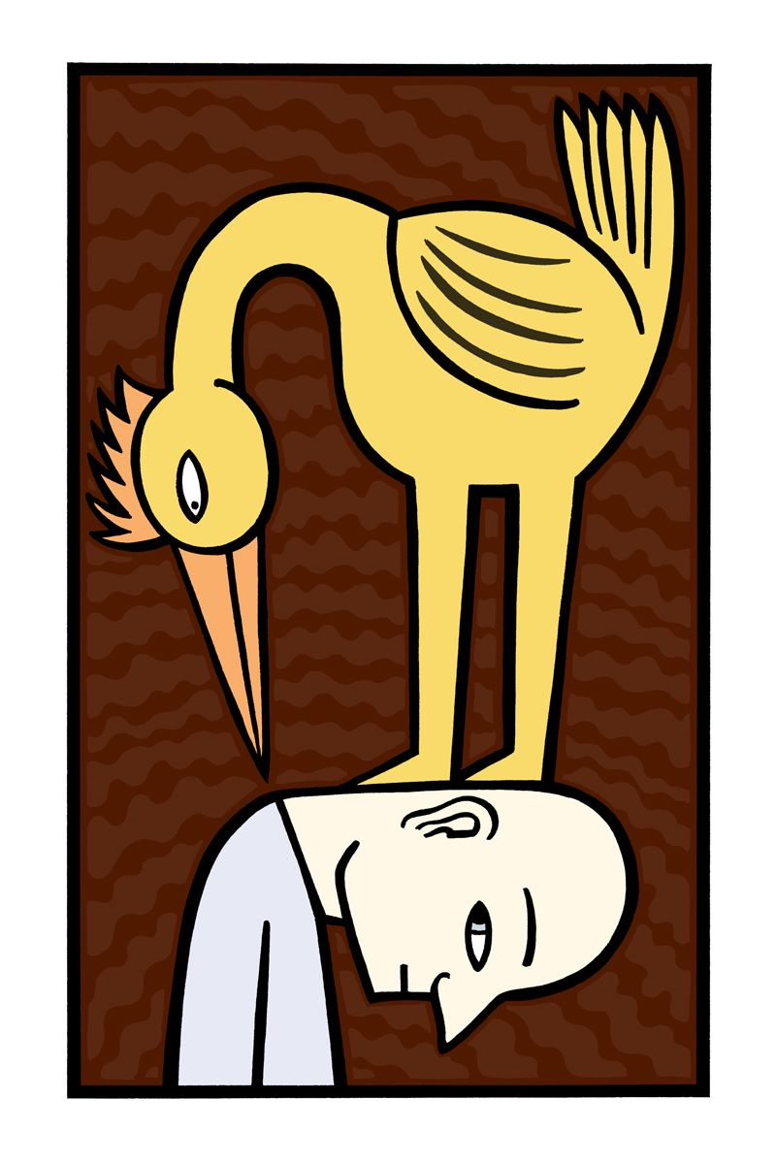
A time for reflection - what fresh insights do you have about this Gospel story and the dynamics of 'truth telling' and 'sticking your neck out'. Image is by Alan Rogerson https://baggelboy.wordpress.com

Song: In Halls of Wealth and Power
In halls of wealth and power where shadowed deals are made,
The heartless ones devour; the helpless are betrayed.
The ones who make decisions seem confident and strong
Yet sometimes blur divisions between the right and wrong.

When Herod chose to wander from living as he should,
John preached with mighty thunder, "Repent and do the good!"
Then power danced with anger; revenge went dancing, too.
When they all join together, what evil they will do!

O God of love and justice, when we feel sure and strong,
May power never tempt us to venture toward the wrong.
In all of our endeavors, give wisdom, Lord, we pray,
That we may love our neighbors and seek your kingdom way.

In halls of wealth and power, in home and neighborhood,
May we reject the evil and turn to what is good.
May justice dance with mercy and service dance with grace;
May nations lift the lowly till peace and love embrace.
(Words: Carolyn Winfrey Gillette; Tune: LLANGLOFFAN)

Offering Prayer
Living and loving God, we bring these offerings for the work of the church, together with our will and power to work for change in our world. Amen.

We raise our concerns for ourselves and others
Loving and living God,
we pray for all those in our world who are suffering from injustice and the abuse of power:
for those who are discriminated against because of race, colour or religion;
for those imprisoned for working for the relief of oppression;
for those who are hounded for speaking the inconvenient truth;
God within, beyond, around – hear our prayer.
for those who unknowingly or deliberately abuse their power:
for those who prevent others from exercising their own power;
for those who take advantage of an imbalance of power when others are vulnerable;
God within, beyond, around – hear our prayer.
for those deprived of reasonable health, housing and education;
for those suffering from hunger and famine;
for those who cry out for employment when there are few jobs;
God within, beyond, around – hear our prayer.
for those too weak to help themselves and seek support;
for those who grieve a loss or suffer from dis-ease;
for those who experience pain or despair;
God within, beyond, around – hear our prayer.
(a period of silence is kept as we pray for people and situations we know)
God within, beyond and around
hear our prayers. Amen.
(Response from the words of Mother Teresa, adapted by Peter Russell)

Today, NAIDOC week draws to a close. We remember and celebrate Aboriginal and Torres Strait Islander people across this wide land. NAIDOC Week each year is an opportunity for Indigenous and non-Indigenous Australians to come together to celebrate not only Indigenous achievement but the history, rich culture, and survival of the oldest continuing living culture on the planet.

Video: Paul Kelly & Ziggy Ramo perform 'Little Things' live on The Set.
https://youtu.be/9Jd3JZb7WVA

(We hold a period of silence)

Please stand for this affirmation of faith.

Affirmation of Faith
God of pilgrim faith,
as we are called together to be your people,
we will seek to live by the values and hope
of Christ Jesus whom we follow.
We will honour one another,
and seek to be an inclusive community
in which each one is given justice, dignity and love.
As your spirit prompts us,
we will seek to discern your will for us
and act on your call in our lives.
We shall be open to discovering your purposes for us
in all aspects of our personal and corporate life.
We commit ourselves to a deepening
of our knowledge and love of you:
in relationship and solidarity with one another,
through worship together and shared reflection,
through faithful action in the wider community,
and in honest fellowship.
We commit ourselves in this our congregation;
for by your love it is here that you have called us to serve.
And we commit ourselves to live in faith
beyond this building and this body;
for we believe we are partners with you
in the ministry of reconciliation in your world. Amen. (Source: Helen Alexander)

Song: SfP 38 Source of our Call
We asked for a home, and you gave us a journey,
faith like a single flame,
weaving light and shadow on an unknown way.

We asked for a sign, and you gave us a vision,
hope, like a dancer's hands
forming shape and substance from tomorrow's day.
Chorus:
Source of our call, and source of our sustaining,
spin into our dance of time
faithfulness in days of doubt,
that we might follow, follow boldly.

We asked for a rest, and you gave us a calling,
peace, like an eagle's rise,
lifting doubt and weakness into certainty.

We asked for love, and you gave us community,
trust, like a desert flower,
bringing joy and beauty in its promised spring.
Chorus:
Source of our call, and source of our sustaining,
renew us by your Spirit rain,
that from the stony days of drought
our lives may rise up, rise up greening.
(Words: Neil Quintrell; Music: Norm Inglis)

We are commissioned, and sent
It is time to go out to share love and power with others,
and to continue our work for justice, mercy and peace in our world.
May we share with others our faith in
the way we live
the words we speak
the deeds of our hands
the prayers in our minds
and the love in our hearts.
May the grace of God-in-Christ renew us,
the enduring love of God support us,
the communion of the Spirit accompany us
this day and into the future. Amen

God's peace be with you. And also with you.
We pass the peace with others in a COVID safe way

This liturgy was prepared by Rev Sandy Boyce (drawing on a variety of sources)

Name of musicians and singers….(usual list)

A-V desk this week is driven by Peter Russell and Greg Bassani

Image: Alan Rogerson https://baggelboy.wordpress.com

Please join us for a refreshments and conversation in Pilgrim Hall.

