HOLY SATURDAY

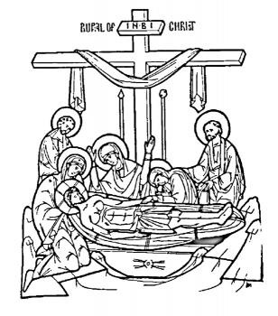

A Service of Prayer and Waiting

GATHERING

A large cross dominates the space which is simple, empty and bare.
There are no cloths on the table, no paraments, no music.
The icon of the burial of Jesus is placed in the sanctuary
with a sand tray, tapers and a single candle before it.
In the centre of the sanctuary is placed a bowl of incense and a bowl of ashes.

The Burial of Jesus

Joseph of Arimathaea with Nicodemus
took the lifeless body of Jesus down from the Cross
and wrapped him in a clean linen cloth with spices
and laid him in a new tomb.

Opening Prayer

O Christ, our way, our truth, our life,
falsely accused by lawless men as a deceiver
buried in a cold stone tomb
and sealed by the hands which had pierced your side
we praise you.

For our sake you were crucified under Pontius Pilate;
suffered death and were buried.
You who gave us the breath of Life
were laid lifeless in a tomb.

O Life, how can you die?
How can you dwell in a tomb?
Yet by your death you destroyed death’s kingdom

and empty the tombs of the dead.

Going down to death, O Life eternal
You dazzled hell with the brightness of your glory
Dispersing all darkness by your light and truth.

In this awesome time of deathly silence
help us stand with you in your emptiness
and wait for the rising of the morning star. Amen

WORD

Psalm 130 Presbyterian Tone 7 Music by Hal Hopson
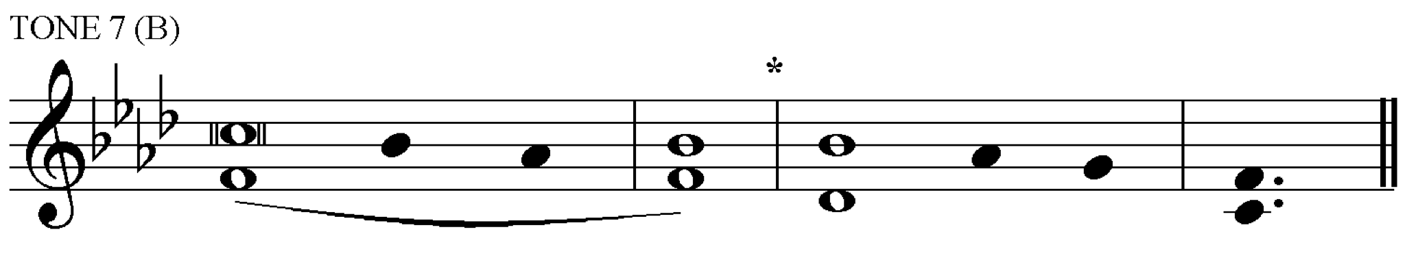

1 Out of the depths have I called to you, O Lord;
2 Lord, hear my voice; *
let your ears consider well the voice of my supplication.

3 If you, Lord, were to note what is done amiss, *
O Lord, who could stand?

4 For there is forgiveness with you; *
therefore you shall be feared.

5 I wait for you, O Lord; my soul waits for you; *
in your word is my hope.

6 My soul waits for the Lord,
more than sentries for the morning, *
more than sentries for the morning.

7 O Israel, wait for the Lord, *
for with the Lord there is mercy;

8 there is plenteous redemption with the Lord, *
who shall redeem Israel from all their sins.

O God,
you come to us in the depths of our darkest despair,
in the suffering of Jesus Christ.
By the rising of your Son,
give us new light to guide us,
that we may always praise your holy name;
through Jesus Christ our Lord. Amen.

Matthew 27: 57-61 The Burial of Jesus

When it was evening, there came a rich man from Arimathea, named Joseph, who was also a disciple of Jesus. He went to Pilate and asked for the body of Jesus; then Pilate ordered it to be given to him. So Joseph took the body and wrapped it in a clean linen cloth and laid it in his own new tomb, which he had hewn in the rock. He then rolled a great stone to the door of the tomb and went away. Mary Magdalene and the other Mary were there, sitting
opposite the tomb.

silence

Reflection

Prayers

Come let us bless Joseph who came to Pilate by night
And begged for the Life of all: ‘
Give me this stranger Who has no place to lay His head.
Give me this stranger, whom His mother saw hanging on the Cross.’

In silence let us offer our prayers for all who are in despair;
all who find this life a hell, and long for release.

silence
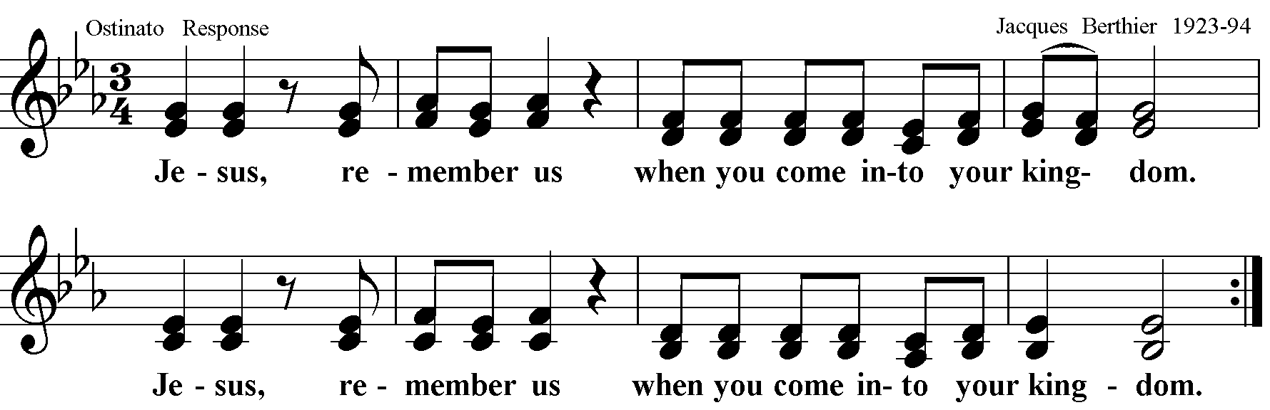

Let us pray for those who are dying,
and those who wait with them.

silence

Response: “Jesus remember us…”

Let us pray for those who through addiction
have lost their health and freedom.

silence

Response: “Jesus remember us…”

Let us pray for ourselves and all whom we love
to be enfolded in the love of God

silence

Response: “Jesus remember us…”

Today a grave holds him
who holds creation in the palm of his hand.
A stone covers him who covers the heavens with glory.
Life is asleep and hell trembles,
and Adam is freed from his chains.
Glory to your saving work,
by which you have done all things!
You have given us eternal rest,
your holy resurrection from the dead. Amen

O God, Creator of heaven and earth:
by Your mercy grant that as the crucified body
of Your dear Son
was laid in the tomb and rested on this holy Sabbath
so we may await with him the dawning of the third day,
and rise with him to newness of life;
who now lives and reigns with you and the Holy Spirit,
one God, now and for ever. Amen

The Lord’s Prayer

Our Father in heaven,
hallowed be your name,
your kingdom come,
your will be done,
on earth as in heaven.
Give us today our daily bread.
Forgive us our sins
as we forgive those who sin against us.
Save us from the time of trial
and deliver us from evil.
For the kingdom, the power,
and the glory are yours
now and forever. Amen.

Closing Responses

I wait for you, O Lord; my soul waits for you;
in your word is my hope.
My soul waits for the Lord,
more than sentries for the morning,
more than sentries for the morning.

There is no blessing.

People may want to light a taper before the icon
as a symbol of their prayer

We go in silence to watch and pray.

