Christmas Carols聖誕頌歌
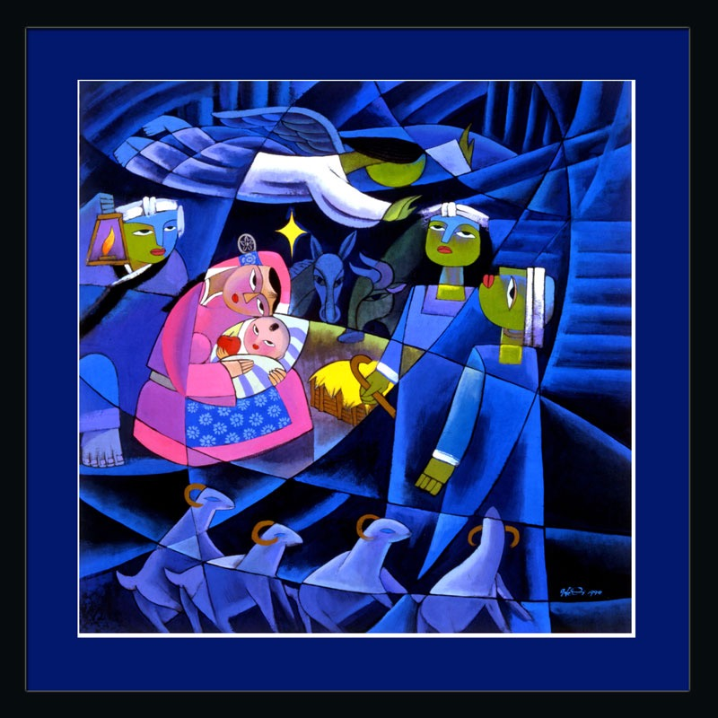

Chinese (SA) Christian Church and Pilgrim Uniting Church
南澳華人基督教會和朝聖堂聯合教會
12 Flinders St, Adelaide
8.15pm, 24th December 2016

Inside cover

In 2016 the Chinese (SA) Christian Church celebrated 15 years since formation. In March 2016, C(SA)CC moved from Maughan Church (which has now been demolished) to Pilgrim Church, where weekly Sunday services are held, along with Sunday School activities, youth and young adults gatherings, Bible Studies, worship for seniors, and other fellowship activities. Services are held in both Cantonese and Mandarin. 二零一六年南澳華人基督教會成立15年。 同年3月，華人教會從蒙恩堂教會（現已被拆除）搬到朝聖教堂，每周禮拜天崇拜，以及主日學活動，青年和年輕成人聚會，聖經研討，和其他團契活動。 語言是普通話和廣東話。

Pilgrim Uniting Church traces its roots back to Adelaide′s early Wesleyans and Congregationalists. A Wesleyan chapel in Pirie Street was opened in 1851 and became known as the Pirie Street Methodist Church located on what is now the Adelaide City Council offices. Stow Memorial Congregational Church, in Flinders Street, was dedicated in 1867. During the 1960s the two congregations began a dialogue which led to a decision in 1969 to become "Union Church in the City”, later changed to Pilgrim Church with the inauguration of the Uniting Church in Australia in 1977. 朝聖堂聯合教會的歷史追溯到阿德萊德的早期衛斯理和公理會。 Pirie街的衛斯理教堂在1851年開始聚會，並且被稱為Pirie街衛理公會教會，位於現在阿德萊德市政廳辦公室。 司都公理會教堂在Flinders街，於1867年獻堂。在20世紀60年代，兩個會眾開始商討決定在1969年成為“都市聯合教會”，後來改名為朝聖教堂，與在1977年合並到澳大利亞聯合教會 。
Pilgrim’s Vision and Mission statement is, ‘We are called by God to be a prophetic witness in the city of Adelaide, so that new life and vitality will be generated in our city and in its people. We celebrate in our unity and diversity, our shared beliefs and past experiences, and value worship, teaching, creativity and justice’.
我們被神呼召作為在阿德萊德市的見證人，使新的生活和活力將產生在我們的城市和其人民。 我們慶祝我們的團結和多樣性，我們共同的信仰和過去的經歷，崇高的敬拜，教學，創造力和正義。

C(SA)CC and Pilgrim Uniting Church work co-operatively and collaboratively to offer a Christian witness in the heart of the city of Adelaide. Together, we are glad to welcome you to this time of celebration as we sing Christmas Carols together and hear the Christmas story in fresh ways through ‘godly play’ and a short address by Pastor Joseph Chai. 南澳華人基督教會和朝聖堂聯合教會攜手合作，在阿德萊德市中心成為基督的見證。 我們很高興一同歡迎您來到這個節慶晚會，因為我們一起唱聖誕頌歌，聆聽聖誕節故事 和柴強牧師的短講 ，以新的方式參加這個“敬虔的聚會”。

Acknowledgement of image on front cover: Nativity by He Qi

Next page

Order of service

Welcome

Carol: O come all ye faithful/讚美詩歌
O come, all ye faithful,
Joyful and triumphant,
O come ye,
O come ye to Bethlehem;
Come and behold Him
Born the King of angels;
O come, let us adore Him,
O come, let us adore Him,
O come, let us adore Him,
Christ, the Lord.
歌詞：
齊來！宗主信徒，快樂又歡欣，
齊來！一齊來，大家上伯利恆。
來朝見聖嬰，新生王已降生 ；
副歌:
齊來虔誠同崇拜，
齊來虔誠同崇拜，
齊來虔誠同崇拜主基督。

Sing, choirs of angels,
Sing in exultation,
Sing, all ye citizens
Of heaven above;
Glory to God,
Glory in the highest;
O come, let us adore Him,
O come, let us adore Him,
O come, let us adore Him,
Christ, the Lord.
天上何其榮華，祂竟甘願捨，
虛心並不嫌，童貞女胎中生。
真主的真主，藉此生，成肉身；

Yea, Lord, we greet Thee,
Born this happy morning,
Jesus, to Thee be
All glory given;
Son of the Father,
Now in flesh appearing;
O come, let us adore Him,
O come, let us adore Him,
O come, let us adore Him,
Christ, the Lord.
救主生於今晨，我眾來歡迎，
天人諸榮耀，完全歸主一身。
大哉！父本像，藉聖子來顯明；

Christmas story with the children: Godly Play (Jenny and Cheng)

Carol: Away in a manger/遠遠在馬槽裡
Away in a manger, no crib for a bed,
The little Lord Jesus laid down his sweet head,
The stars in the bright sky looked down where he lay,
The little Lord Jesus asleep on the hay.
遠遠在馬槽裡，無枕也無床，小小的主耶穌，睡覺很安詳；
眾星都照耀著主安睡地方，小小的主耶穌，睡在乾草上。
The cattle are lowing, the baby awakes,
But little Lord Jesus no crying he makes.
I love you, Lord Jesus; look down from the sky,
And stay by my side until morning is nigh.
眾牲畜嗚嗚叫，聖嬰忽驚醒，小小的主耶穌，卻無啼哭聲。
主耶穌，我愛你，求靠近我旁，坐在我小床邊，看守到天亮。
Be near me, Lord Jesus, I ask you to stay
Close by me for ever, and love me, I pray.
Bless all the dear children in your tender care,
And fit us for heaven, to live with you there.
求主來臨近我，與我在一起，愛護我，親近我，永遠不分離。
求主賜福孩童，常關懷看顧，讓我們在天家與耶穌同住。

Prayer禱告 (Pastor Chai and Cheng柴牧師和陳誠)

Carol: Hark the herald angels sing/听啊，天使高声唱
Hark the herald angels sing
"Glory to the newborn King!
Peace on earth and mercy mild
God and sinners reconciled"
Joyful, all ye nations rise
Join the triumph of the skies
With the angelic host proclaim:
"Christ is born in Bethlehem"
Hark! The herald angels sing
"Glory to the newborn King!”
听阿，天使高声唱：
督“荣耀归与新生王，
督恩典临地平安到，
督神、人此後能和好。
督兴起！地上众生灵，
督响应天上讚美声；
督天唱地和乐欢腾，
督“基督降生伯利恒。
督天唱地和乐欢腾，
督“基督降生伯利恒。
Christ by highest heav'n adored
Christ the everlasting Lord!
Late in time behold Him come
Offspring of a Virgin's womb
Veiled in flesh the Godhead see
Hail the incarnate Deity
Pleased as man with man to dwell
Jesus, our Emmanuel
Hark! The herald angels sing
"Glory to the newborn King!”
基督本有神形像，
督原是永远王，
竟在末世从天降，
生於童女成人状；
神性穿上血肉体，
道成肉身何奥祕，
甘愿作人同人住，
以马内利是耶稣，
甘愿作人同人住，
以马内利是耶稣。
Hail the heav'n-born Prince of Peace!
Hail the Son of Righteousness!
Light and life to all He brings
Ris'n with healing in His wings
Mild He lays His glory by
Born that man no more may die
Born to raise the sons of earth
Born to give them second birth
Hark! The herald angels sing
"Glory to the newborn King!”
欢迎天来和平王，
欢迎公义的太阳！
督带来生命与亮光，
督使人复活医人伤；
督虚己撇下祂荣光，
督降生救人免死亡，
督降生使人得重生，
督降生使人能高升，
督降生使人得重生，
督降生使人能高升。

Sending out
The story has been told.
But the story has not yet ended.
The story includes each of us, we all play a part.
So let us go out to live the story,
to tell of the Hope that is being born among us this Christmas,
to share the Love of the season with the world,
to be agents of Peace in times of trouble,
to sing songs of deep and abiding Joy.

Blessing祝福
May the song of the angels愿天使的歌聲
the joy of the shepherds牧羊人的喜乐
the wonder of the wise men智慧者的奇迹
and the peace of the newborn king和新生王的和平
fill our hearts and homes充滿我们的心灵和家庭
this Christmastime and always. Amen. 这个圣诞节直到永遠。 阿门。

Carol: Joy to the world/普世欢腾
Joy to the World , the Lord is come!
Let earth receive her King;
Let every heart prepare Him room,
And Heaven and nature sing,
And Heaven and nature sing,
And Heaven, and Heaven, and nature sing.
普世欢腾! 救主下降!大地结她君王;
惟愿众心, 预备地方, 诸天万物歌唱.
诸天万物歌唱, 诸天万物歌唱.
Joy to the World, the Saviour reigns!
Let men their songs employ;
While fields and floods, rocks, hills and plains
Repeat the sounding joy,
Repeat the sounding joy,
Repeat, repeat, the sounding joy.
普世欢腾! 主治万方! 民众首当歌唱;
沃野洪涛山石平原, 响应歌声嘹亮,
响应歌声嘹亮, 响应歌声嘹亮.
He rules the world with truth and grace,
And makes the nations prove
The glories of His righteousness,
And wonders of His love,
And wonders of His love,
And wonders, wonders, of His love.
主藉真理恩治万方, 要使万邦证明,
上主公义, 无限荣光, 主爱奇妙莫名
主爱奇妙莫名, 主爱奇妙莫名.

Thanks to all those who have supported this service through music and word, story and song, and to all those who have attended. 感謝所有通過音樂，文字，故事和歌曲支持這項事工的人們，以及所有參加者。

