Pilgrim Uniting Church
12 Flinders Street, Adelaide
Ash Wednesday 5 March 2014

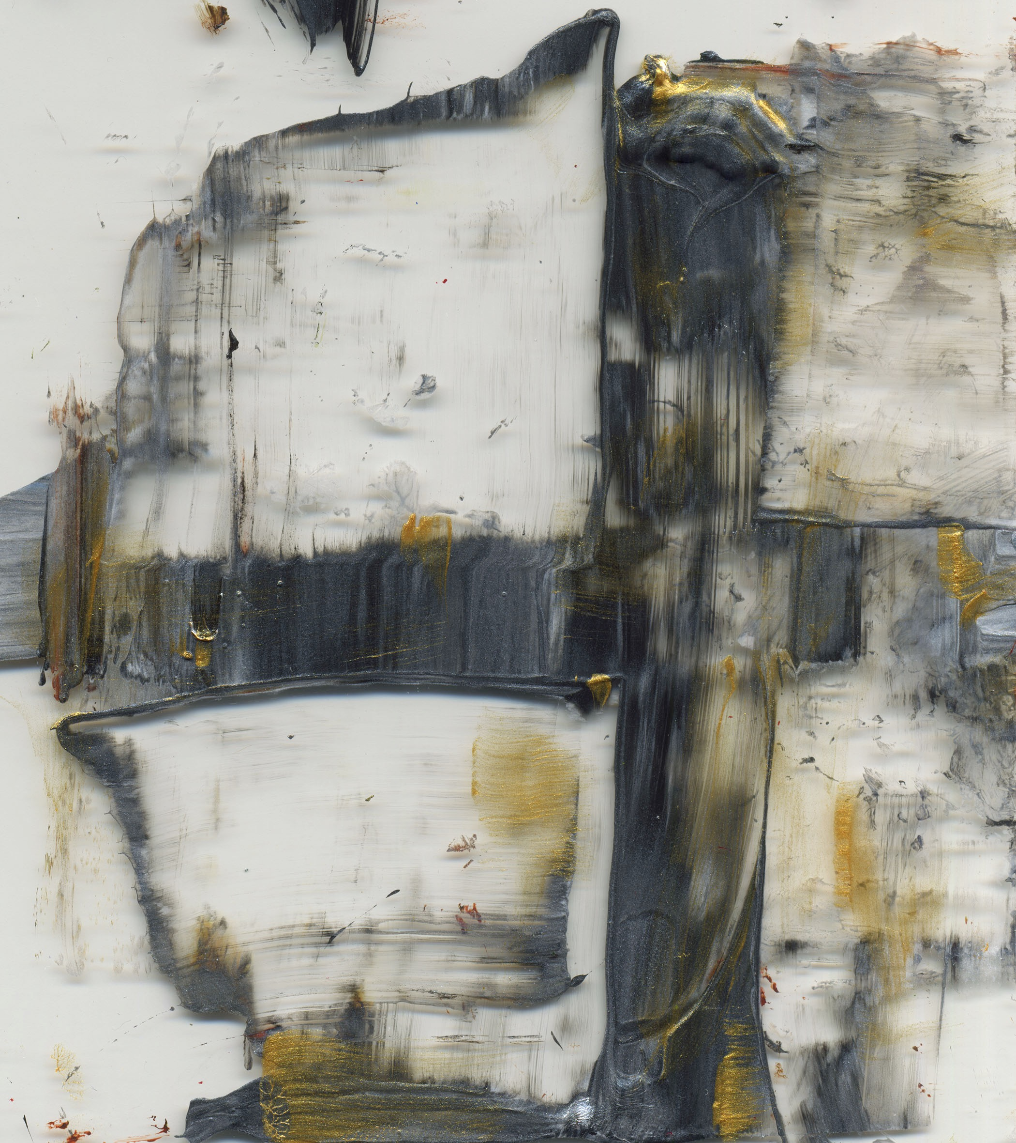

Blessing the Dust by Jan Richardson (used by permission)

WELCOME
OPENING SENTENCES
Journeying in earthliness writ large, living deeply within our honest searchings, immersed in the rawness of our temptations:
The Christ holds the faith in fragile arms.

Standing in the wilderness, surrounded by our toughest questions
and human in every struggling way:
The Christ walks with life wide open ahead of us,
truly human, truly God,
trustworthy in life and trustworthy in death.

PRAYER OF INVOCATION
Wonder of wonders! God is to be found within our wildernesses, deep in the centre of our harshest places and placing a caring hand under all our questions. Be known to us here, O God, whether we are on firm ground
or the treacherous sands of indecision.
Come, gracious Jesus, come. Amen

LIGHTING OF THE CANDLE

PRAYER OF CONFESSION
O Jesus, as we listen to the story of your temptations, we realise that we are hearing something like your confessions, the struggles that lay within your earthly life. Even though you unswervingly chose for good and truth,
we know that you will believe us when we share how hard it is to choose that way. In the silence of our own wilderness, we know who we are and what challenges our life. A silence is kept.

Forgive us, O God, when we would rather not pause and stay within
all that lies in the shadowy wilderness of our lives, preferring to press on and leave things for another day. A silence is kept.

Forgive us, God.
Call us away from this temptation.

If we hold endlessly into grappling with our questions because we do not want to hear the answers: Forgive us, God.
Sound your truth strongly into our hearts
in the voice of one who knows us well. Amen
WORD OF ASSURANCE
There is no wilderness in life which is out of bounds for God.
In Christ, we are forever joined with a grace which comes from earthly experience. We are forgiven.
Thanks be to God.
READINGS:
Our first reading is the story of Jesus in the wilderness, facing his vulnerabilities and the temptations of power.

Matthew 4: 1-11
4Then Jesus was led up by the Spirit into the wilderness to be tempted by the devil. ²He fasted forty days and forty nights, and afterwards he was famished. ³The tempter came and said to him, “If you are the Son of God, command these stones to become loaves of bread.” ⁴But he answered, “It is written, ‘One does not live by bread alone, but by every word that comes from the mouth of God.’” ⁵Then the devil took him to the holy city and placed him on the pinnacle of the temple, ⁶saying to him, “If you are the Son of God, throw yourself down; for it is written, ‘He will command his angels concerning you,’ and ‘On their hands they will bear you up, so that you will not dash your foot against a stone.’” ⁷Jesus said to him, “Again it is written, ‘Do not put the Lord your God to the test.’” ⁸Again, the devil took him to a very high mountain and showed him all the kingdoms of the world and their splendor; ⁹and he said to him, “All these I will give you, if you will fall down and worship me.” ¹⁰Jesus said to him, “Away with you, Satan! for it is written, ‘Worship the Lord your God, and serve only him.’” ¹¹Then the devil left him, and suddenly angels came and waited on him.

In our second reading, Jesus instructs the disciples about how to practice piety with faithfulness and humility.

Matthew 6:1-6, 16-21
6‘Beware of practising your piety before others in order to be seen by them; for then you have no reward from your Father in heaven.
2 ‘So whenever you give alms, do not sound a trumpet before you, as the hypocrites do in the synagogues and in the streets, so that they may be praised by others. Truly I tell you, they have received their reward. ³But when you give alms, do not let your left hand know what your right hand is doing, ⁴so that your alms may be done in secret; and your Father who sees in secret will reward you.*
5 ‘And whenever you pray, do not be like the hypocrites; for they love to stand and pray in the synagogues and at the street corners, so that they may be seen by others. Truly I tell you, they have received their reward. ⁶But whenever you pray, go into your room and shut the door and pray to your Father who is in secret; and your Father who sees in secret will reward you.’
16 ‘And whenever you fast, do not look dismal, like the hypocrites, for they disfigure their faces so as to show others that they are fasting. Truly I tell you, they have received their reward. ¹⁷But when you fast, put oil on your head and wash your face, ¹⁸so that your fasting may be seen not by others but by your Father who is in secret; and your Father who sees in secret will reward you.’

QUESTIONS FOR REFLECTION (silence is held for quiet contemplation)
The season of Lent which begins with this ceremony and lasts for forty days is a time for quiet reflection following the pattern of the story of Jesus on spiritual retreat in the wilderness. During that time, Jesus was faced with temptations to use his power for personal gain alone, exclusive of the common good. In what areas of your life are you tempted along these same lines?
Jesus instructed his disciples to be authentic about their spiritual lives and to seek genuine relationship with God rather than simply keeping up faithful appearances. How is God calling you to deeper and more authentic spirituality?

PRAYERS OF INTERCESSION
Visit us now in the centre of the wilderness of our life, O Christ.
Hold firm among our frail holding to truth,
stand tall when we would lower our life’s aspirations,
speak boldly into our false assumptions
and look us in the eye when we fool ourselves
by pretending to be doing your will. A silence is kept.
Make transparent the wiles of those who would tempt us,
calling to us in voices of sweetness and reason
while attempting to capture our very souls. A silence is kept.
Be with all those today who need your company in the wilderness of their lives. Especially we remember people and situations in our world and in our hearts:
Silence for personal prayers of intercession

Remind us, O Christ, of your true way.
Go with us along the path of humility,
in the spreading of good and justice and compassion in the world,
in offering love which is not founded on our own gain
and in finding peace which is beyond describing. Amen

CEREMONY OF THE ASHES
You are invited to come forward and receive the symbol of the ashes marked as sign of the cross on the forehead. Receiving this symbol marks our acknowledgement of our own vulnerability and mortality and the renewal of our commitment to follow Christ with humility and hope.
People come forward to receive the symbol of the ashes
Ashes… earth brings us into life and nourishes us.
Earth takes us back again,
Birth and death are present in every moment (Thich Nhat Hanh/ep).

WORDS OF MISSION AND BLESSING
The world is often found by passing through the wilderness.
Go in courage because Christ has walked this way before us.
May truth shine as a star in the night sky, righteousness be found in the centre of our confusions, and God be in our beginning, our centre and our endings. Amen
Will you meet us – a blessing for Ash Wednesday
by Jan Richardson, www.paintedprayerbook.com
Will you meet us  in the ashes  will you meet us  in the ache  and show your face  within our sorrow  and offer us  your word of grace: | That you are life  within the dying  that you abide  within the dust  that you are what  survives the burning  that you arise  to make us new. | And in our aching  you are breathing  and in our weeping  you are here  within the hands  that bear your blessing  enfolding us  within your love.

A reflection on Ash Wednesday – Bruce Eppersley
Traditional Ash Wednesday liturgies focus on the brevity of life and remind worshippers that they came from dust and will soon enough return back to the earth, dust once more. For our parents in the faith, Lent was a morose season in which they gave up something in order to prepare themselves for eternal life. The salvation promised and hoped for required turning our backs on the joys of embodiment and the beauties of the earth. Faithful Christians trained their eyes on heaven, forsaking time for eternity. Yes, life is serious and risky business, and no one gets out alive. But is salvation about escaping this world of perpetual perishing or seeing everlasting beauty in each passing moment?
For years, I struggled with Ash Wednesday services precisely because of their otherworldliness and asceticism. My self-denial in Lent was typically half-hearted and short-lived. These days, I am reconsidering the meaning of Ash Wednesday. The brevity and uncertainty of life now invites me to praise, wonder, and beauty, and to seize the moment—for this is the day God has made and I will rejoice in it! All that I love and care for is mortal and transitory, but mortality is the inspiration to celebration and love. Plato once described time as the moving image of eternity. We are constantly dying, but we are also constantly living as we reflect God's vision in the world of the flesh. This day, this moment, is a "thin place," for God is with us, revealed in flesh, blood, and healing touch.
This Ash Wednesday, I'm letting go of everything that keeps me from rejoicing in the passing beauty of the earth. Yes, we are dust, but we are earthly dust, springing forth from a multi-billion-year holy adventure. Dust is good, after all; it is the place of fecundity, of moist dark soil, and perhaps we are "star-dust” (Rex AE Hunt) emerging from God's intergalactic creativity. We are frail, but we are also part of a holy adventure reflecting God's love over billions of years and in billions of galaxies.
Ash Wednesday causes us to pause, notice, wake up, and discover that "God is in this place" and now we know it! With author Patricia Adams Farmer (in Embracing a Beautiful God), Ash Wednesday invites us to take a "beauty break," open to the awe-filled, precarious world in which we live.
So this Ash Wednesday, I plan on considering the lilies and the birds of the air. I will no doubt share in the Liturgy of Ashes, but not the ashes of world-denial or bodily-mortification. The ashes I'll accept will be the ashes of transformation, of awakening to beauty and love, of seizing the moment.
In some liturgies, the imposition of ashes is accompanied by the words, "repent and believe the gospel." And that I plan to do this year. I plan to "repent," turn around, live more in the moment, appreciating God's grandeur, and believing the good news—the embodied, yet ever-lasting, gospel of beauty, wonder, and grace—the good news of walking with beauty all around me.
(adapted, http://www.patheos.com/Resources/Additional-Resources/Seize-the-Day-Reimagining-Ash-Wednesday-Bruce-Epperly-03-03-2011.html)

