9.30am service 4th September 2016

Season of Creation: Week 1: Water

(This service incorporated a number of creative elements including a ‘soundscape’. The following is the printed order of service printed for Week 1 of Season of Creation)

Lighting of the candles

Opening video: ‘She’s alive, beautiful, finite, dying, worth dying for’ (youtube clip)

Opening prayer of thanks
We give thanks, O God of life, for the gift of water. We encounter water in many different forms - ocean, lake, fountain, river, rain, pool, puddle, tears. Before the world had shape and form, your Spirit moved over the waters. For us, as living creatures, water has a special meaning because some entity that could be distinguished as Life first drifted in shallow waters - reproducing, evolving, yielding that endlessly varied stream of living things that has surged through time and space to occupy the earth. We are part of that evolving stream of life. You have come to us through water, O God, in the stories of Jesus who was nurtured in the water of Mary’s womb, baptized by John in the water of the Jordan, and became living water to a woman at the Samaritan well. Jesus washed the feet of the disciples and sent them forth to baptize with water and spirit. May the water always remind us all of your steadfast love and abiding presence. Amen.

Acknowledgement of land
The designer of the Three Rivers fountain in Victoria Square, sculptor John Dowie, was inspired by both tradition and site. He noted, ‘It’s an ancient tradition for fountains to honour the gods of the rivers that feed it. We have no river gods, but the water feeding this fountain will come from the Murray, the Onkaparinga and the Torrens’. This fountain is symbolic of these rivers, represented by human figures and birds. Dowie made two of the rivers female figures - a woman and a black swan for the Torrens, and a woman with a heron for the Onkaparinga. These were cultivated areas, so the women are European. The old substantial Murray is male and depicted as an Aboriginal man holding an ibis. We acknowledge the Kaurna people who met on the land, and the waters of life that have sustained them, and continue to sustain us. We commit ourselves again to reconciliation in this land.

Gathering (welcomer)
We gather here this day, as people drawn to a well, seeking life-giving water, finding common grace as stories are shared, as hope is found, as peace is exchanged. All are welcome!
Song: Spirit of Peace SfP 39

Passing of the peace - please pass a sign of peace to those around you.

Brief Introduction to the Season of Creation series.

(followed by):The paper ‘tear’ held in your hand will guide you through the service. Please write a word or phrase prompted by words in the order of service, your own reflections, a new way forward, a prayerful thoughts. Perhaps it’s a reflection on the natural rhythms and patterns in your life. The way you’re pulled this way and that in opposition to how your body wants to move and your spirit to be. It might be where in your life you feel the invitation to embrace the sacred flow of the river in your life. It might be the places in your life that are ebbing and flowing. At any time during the service, please come forward and pin the tear on the ribbon fabric at the front.

When we recognize ourselves as part of the earthly community, we begin to see the profound mystery at work.
The mystery in the natural world….
….powerfully reveals the Mystery in the depths of our own souls.
To be fully present to the gifts of creation can guide us along paths for our own spiritual growth.
We re-discover a God who dwells at the heart of all living things.
A creator who sustains and transforms creation….moment by moment.
A divine source who sent Jesus to speak in parables and metaphors about the natural world.
God’s deep-rooted presence within us awakens our sleepy potential.
Reflecting upon God as revealed in nature will serve to strengthen our sense of the sacred in our midst.
With renewed awe and gratitude, we acknowledge a deity whose immanence shimmers through all creation.
We are connected to that same matrix of life.
We are called to cherish and protect the created world….
….to be mindful of its fragile wonders and therefore our responsibility to curb consumption.
In this Season of Creation, we prayerfully contemplate the continuing revelation of the divine nestled as profound gift and disturbing challenge within the holy elements of Water, Wind, Earth and Fire.
A time of silence
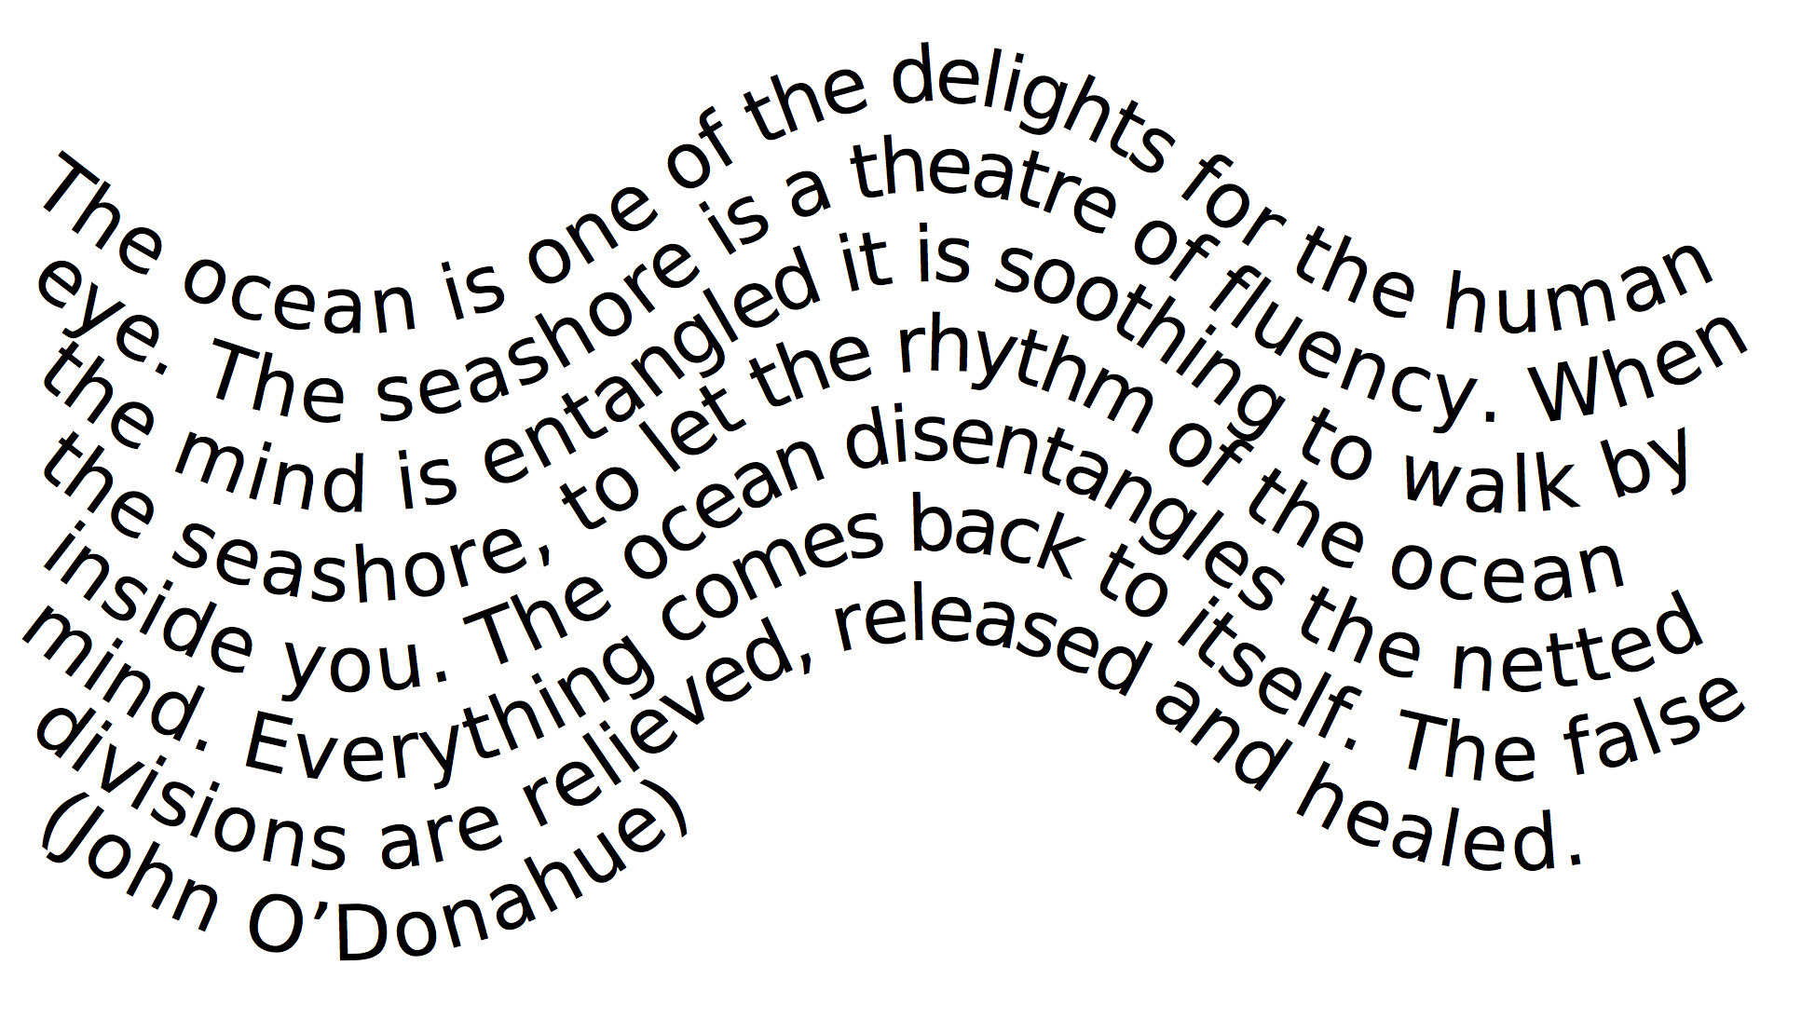
Poem: Deep Waters
Empty me O God that I may be filled.
Lead me
Lead me down
Lead me down into the depth of You.
Stay with me
Stay with me and speak to me
Stay with me and speak to me in silence.

Song (solo) : Deep Water
(Please join in as you are able after it is sung once, or simply use the music for reflection)
Deep waters flowing
calling all to follow
Watching, listening, waiting
silence finds a home. (repeated 5 times) (words and music: Trisha Watts)
For reflection:
May what I do flow from me like a river,
no forcing and no holding back,
the way it is with children.
Then in these swelling and ebbing currents,
these deepening tides moving out, returning,
I will sing you as no-one ever has,
streaming through widening channels
into the open sea. (Rainer Maria Rilke)

Reading and Reflection
Song: You were in this place SPG4 101

Video: Rev Dr Seforosa Carroll (Uniting World) reflects on water from a Pacific perspective

Prayers for others: ’Message in a bottle’ - the poets speak to us
(‘Messages’ were retrieved from each of the bottles, and read out - a desperate plea)
Think about those who cross the seas in search of freedom and refuge.
“No-one leaves home unless home is the mouth of a shark
You only run for the border when the whole city is running as well.
You have to understand that no-one puts their children in a boat
unless the water is safer than the land”. (Poet: Warsan Shire)
The island of Midway in the middle of the Pacific is full of albatrosses, and also by garbage. Plastic is so ubiquitous on Midway that every single albatross on the island will likely die with a stomach full of it. When birds die and decompose, the plastic in their guts remains.
“Anywhere you see a big pile of plastic but nothing else
that’s where an albatross died.
When the time comes for them to cut me open,
I wonder how plastic they’ll find me?
What’s happening on Midway
is that we have turned albatross into canaries
warning us that what affects the ocean
will eventually reach us on land.
Dolphins laugh to keep from crying
as our neglect becomes their poison.
Entanglement.
Destined to last forever, destined to be used only once.
Every molecule of plastic ever created
is still somewhere on the planet
We are still working towards the
great galactic rubbish dump.
The writing on the wall is clear:
every drop of water there is or was or ever will be
exists right now.
When we have finally suffocated the ocean
with plastic bags - millions by the minute -
and when it is humans who starve (lacking an ability to digest legos)
who will be left to remember and say
that plastics made it possible?”
(Poet: Chase Wiggins, adapted)
Kirabati poet Teweiariki Teaero described the atolls of his homeland as 'Garlands of the gods.' Many low-lying reef island Pacific nations are threatened by rising sea levels, coastal erosion and stronger trade winds. In the past 20 years, sea levels have risen 7 mm per year. In the past 2 years, 5 tiny Solomon islands have disappeared, with 6 experiencing severe erosion. ...Built by the sea, now being reclaimed by the sea....By building higher seawalls and the drastic action of communities relocating to different islands, this third bottle sends the Kirabati poet's fragile hope that these islands will "rise over the troubled seas.”

Blueness prayer
Dear God, there are times
when your message comes to us rather insistently,
almost like a tapping that swells on the tide of our busy lives …
We hear your voice most clearly
at the edge of waters,
calling us back to creation
to feel again the freshness of you
running through everything
like a crystal blue current.
God of amazing blues, you know well our tendency
to fill our lives with our own methods of communication.
Thank you for constantly returning us to the simplicity of yours.
Again we experience you in the rejoicing
of bare feet making watery footprints on a loose sandy shore,
in the wonder of light that plays amongst
a drowsy drift of seagrasses underneath a jetty,
in the myriad textures of waves depending on the weather
and the delightful kaleidoscope of ocean blue hues in the Pacific,
from central tropics to the icy polar opposites.
You are there in every single drop.
Beloved Creator, coming to such blue majesty
is always a coming home,
a time of peace and grace
as the unimportant in us falls away
and we know again that the source of all beings
comes from you
and is one with you,
bright and beautiful God.
(Rose Milton-Head, adapted from a WCC prayer)

For reflection
Like the sea itself, the shore fascinates us when we return to it, the place of our dim ancestral beginnings. In the recurrent rhythm of tides and surf and in the varied life of the tide lines there is an obvious attraction of movement and chance and beauty. There is also, I am convinced, a deeper fascination born of inner meaning and significance. When we go down to the low tide line, we enter a world that is as old as the earth itself - the primeval meeting place of the elements of earth and water, a place of compromise and conflict and internal change. For us, as living creatures it has a special meaning as an area in or near which some entity that could be distinguished as Life first drifted in shallow water - reproducing, evolving, yielding that endlessly varied stream of living things that has surged through time and space to occupy the earth.
Rachel Carson.

Song: TiS 668 Touch the earth lightly
(the offering will be collected during the song)

Offering prayer
Faithful God, you ask us to be faithful people.
In this community, you ask us to be people of justice.
In this community, you ask us to be people of compassion.
In this community, you ask us to be people of peace.
Be with us as we try to be faithful
in large ways and in small ways
so your eternal community may come in every way. Amen.
We recognise and bless the gifts brought to the table and those given to support the mission of the church through automatic payment.

We are invited into a baptism of belonging
Water is poured into two bowls and into font
Baptise us all, O Holy One, into a new way of being, a new humanity, fit for the glory and dignity of this one Earth community. Blend with these baptismal waters our tears for all that we have done, and left undone, all those we have left behind and left unloved. Drown us in the deep awareness of the kingdom of God, of our radical belonging in you, and with each other, and with all creation. Raise us up, a new creation gasping for life, that we might grasp the full extent of the mystery of being - alive! creative! compassionate! Now we die with Christ, that we might also be raised up with Christ, to throw our arms around this wondrous planet in a holy and healing embrace. Amen.
(Bruce Sanguin)

Reflecting and praying….a time of silence

Song: Let it be living water V.1&3 SPG4 50 (please remain seated)
(2 water bowls are taken to plinths near the eastern porch)

Sending out
We go from here to enable that which has been raised here. We began our service with worship. And now we leave, to continue our worship with service. As we do, we will go through the waters of baptism. You are invited to dip your fingers into the water and touch your forehead with it, praying that your spirit might be filled with the fluidity of water.
You may trace the sign of the cross on your forehead as a sign of your own commitment to care for God’s creation. Remember always, you belong to Christ. And may the peace of Christ be always with you. And also with you.

Please leave in silence.
A blessing
Deep peace of the running wave to you,
of water flowing, rising and falling,
sometimes advancing, sometimes receding….
May the stream of your life flow unimpeded!
Deep peace of the running wave to you! (Celtic prayer)
This service was prepared by Rose Milton-Head and Sandy Boyce. Thanks to the musicians who offer their skills to us each week, and Norm Inglis for his leadership today, and to Colin Telfer who led our singing. Thanks to the technical support on the day and also to Peter Russell and Allan Forbes for endless encouragement and practical support for our services. Please join us for morning tea in the hall.

