Pilgrim Uniting Church
12 Flinders Street, Adelaide
8.00am MORNING WORSHIP

COCU49A.PENTECOST8A 30 JULY 2017

GREETINGS, WELCOME and COMMUNITY NEWS
CALL TO WORSHIP (inspired by Hebrews 10:19-22)
We gather together to worship, knowing that God is already here among us; knowing that there is nothing that separates us from the presence of our Lord. Wherever we are, wherever we go, God is near. So let us enter into this service of worship with confidence and hope, knowing that God is already with us, that God stands eager to meet us and bless us with love.

PRAYER OF INVOCATION (based on Psalm 105:1-11)
O Lord, our God, where is there another God like you - a God of justice and unfailing love, who stands by the promises made to God’s people,
generation after generation? There is no other. You alone are God.
And so we gather together to worship You:
to give you thanks, to proclaim your greatness,
to sing your praise, to seek your face,
and to celebrate your faithful presence with us.
We pray that your Spirit would guide and inspire our worship:
Open our mouths to sing and speak your praise,
open our ears to hear your Word,
open our eyes to see to you at work among us,
open our hearts to receive your love. Amen. (Christine Longhurst)
HYMN TIS #152 Joyful, Joyful we adore you

PRAYER OF CONFESSION (inspired by Matthew 13:31-32)
Loving God, we remember with gratitude those people who generously sowed the seeds of faith in our lives. We give thanks for the ways you have blessed our lives with the gift of the Holy Spirit so that our faith may grow. Pause for a time of reflection. We confess the times we fail to plant seeds of faith in the lives of others; the times when our personal priorities and responsibilities absorb all of our energy and we neglect the opportunity to encourage others in their faith; the times when our lives become entangled with the values of the world. God of grace, we know that when we become disconnected from you, our lives becomes parched and unfruitful and our faith becomes stunted and dry. (Moira Laidlaw, adapted)
A time of silence as we reflect on these words for ourselves

WORDS OF ASSURANCE
O give thanks to God who hears our prayers:
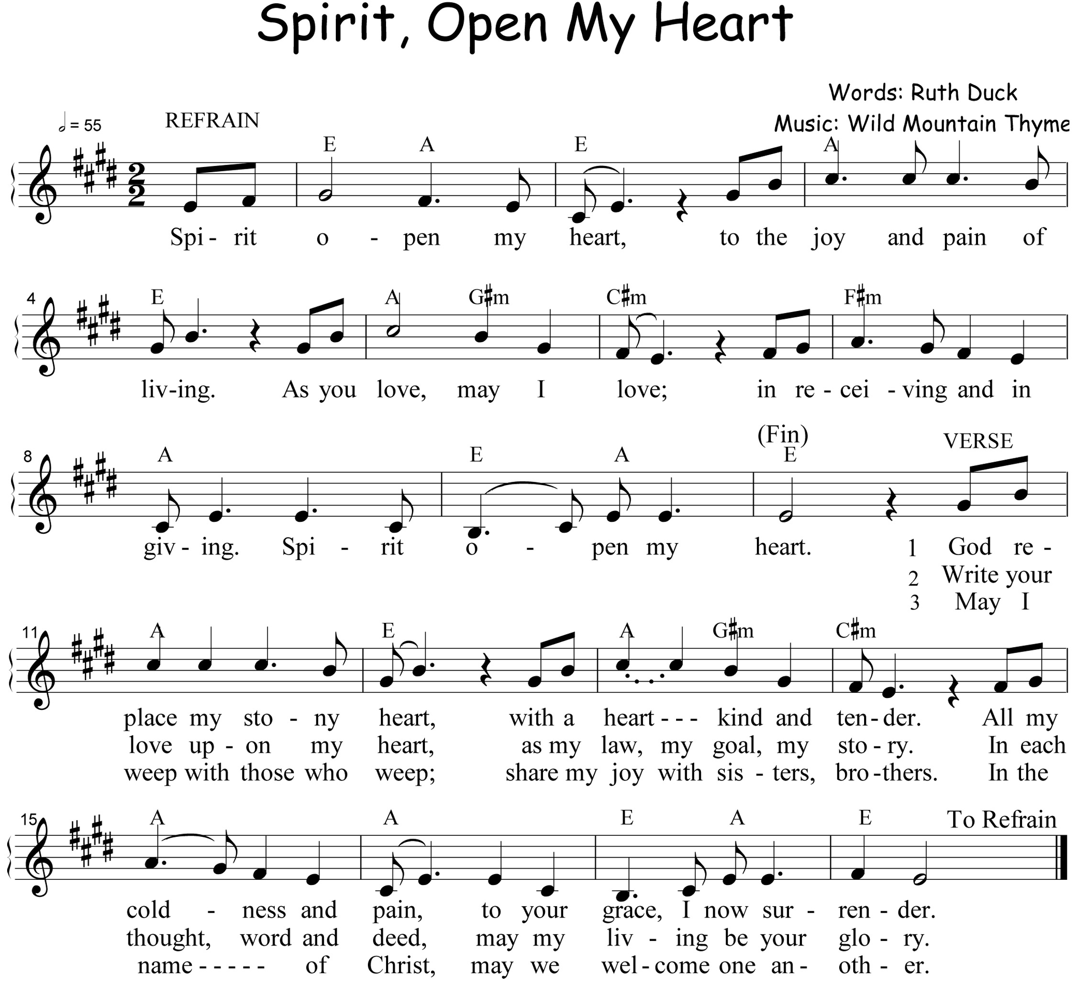
Bless and renew our lives so that we remain connected to you at all times and in all places. Strengthen our faith to expand and grow so we may bear the fruit of your mercy, your love, your undying life. Amen.

BIBLE READINGS: Genesis 29:15-28 Matthew 13:31-33, 44-52
REFLECTION

PRAYERS OF INTERCESSION
(Romans 8:26-28) ”The Spirit helps us in our weakness. We do not know what we ought to pray for, but the Spirit intercedes for us through wordless groans. The One who searches our hearts knows the mind of the Spirit, because the Spirit intercedes for God’s people in accordance with the will of God. We know that in all things God works for the good of those who love him, who have been called according to his purpose”.
Prayers are offered….this is my prayer/this is our prayer.
(Romans 8:31b,35,37-39) “If God is for us, who can be against us? Who shall separate us from the love of Christ? Shall trouble or hardship or persecution or famine or nakedness or danger or sword? No, in all these things we are more than conquerors through him who loved us. For I am convinced that neither death nor life, neither angels nor demons, neither the present nor the future, nor any powers, neither height nor depth, nor anything else in all creation, will be able to separate us from the love of God that is in Christ Jesus our Lord”.
Let it be true that nothing can separate us from your love, O God, and let the truth of your love be in our thoughts, words and deeds so that our world will be brought back together, reunited with common purpose and rejoined to the good. We offer our prayers in the name of Jesus who taught us to pray:

THE LORD’S PRAYER (words on inside page of hymn book)

HYMN TIS #254 O changeless Christ
During the singing of this hymn, we will receive our offering for the work of the church in the world.

PRAYER OF DEDICATION
May God bless our giving as signs of the kingdom: bread for all, pearls of wisdom, plenty to share. Let it all work together for the good, bringing hope to any who feel they are lost and reminding us all of God’s constant love. Amen

HOLY COMMUNION

THE INVITATION

THE NARRATIVE OF THE LAST SUPPER

THE GREAT PRAYER OF THANKSGIVING
God be with you. And also with you.
Let us open our hearts. We open them to God.
Let us give thanks to the Lord our God.
It is right to give our thanks and praise.
We give you all thanks and praise, O God, for you are faithful to the covenant you have made with a thousand generations. You are the Ground of Being, the source of every living thing, and in all things you work for good for your chosen ones. Your servant Jacob laboured seven years for the love of Rachel; and for love of us, your child Jesus has laboured all the way to death. Jesus came among us, sowing your Word, and from that tiny seed your kingdom has grown, a pearl of great price, a treasure for which we would give everything, a home of welcome and grace for all people. Though rulers and powers turned against him and he was killed, you raised him to new life. Now there is nothing in all creation that can separate us from the love given us in Christ. Therefore, with our hearts lifted high, we offer you thanks and praise at all times through Jesus Christ our Lord, who lives and reigns with you and the Holy Spirit, one God, for ever and ever. Amen.

PRAYER OF CONSECRATION
Pour out your Holy Spirit upon us that this meal may be a communion in the life and love of Christ; empowering us to work for the good in all things. Unite us in faith, encourage us with hope, inspire us to love. Amen.
Communion is shared

PRAYER AFTER COMMUNION
We give thanks to you, God. We see you in our lives and in the lives of others - and know that you are good. You call us, know us, guide us. No matter what happens in our lives, you have never, nor will you ever, abandon us. Be with us as we seek to understand and embody your goodness in the world. Amen

WORDS OF MISSION AND BLESSING
If we held a pearl of great value in our hands, would we sell everything and buy it? If we could make the bread rise to feed the hungry, would we remember to put in the yeast? If we were fishing and the nets began to fill,
would we work side by side to share the bounty?
Help us to say ‘yes, we understand’, that the kingdom of heaven is within, to be lived, trusted and shared.
God give you the courage to speak your mind. Christ give you the love to conquer all adversity. Spirit give you hope and help you keep it together
in a shattering world.

The peace of Christ be always with you. And also with you.
The sign of the peace is exchanged.
Please stay for a light continental breakfast following this service.

